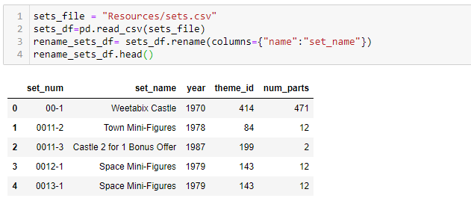



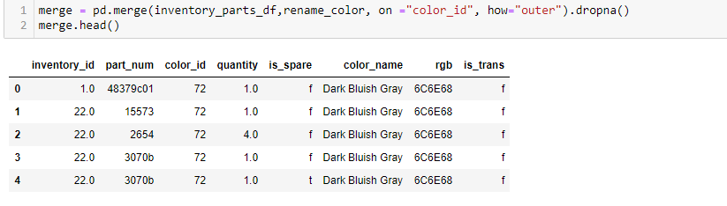

**The final production database to load the data into SQL.**

We used relational database postgres SQL to upload our datasets.

By creating connection engine from pandas.

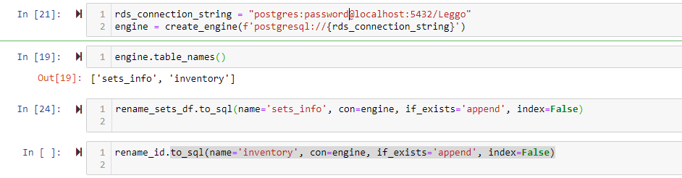

**· The final tables or collections that will be used in the production database.**

We run the query to get the quantity of parts available for the particular set_num.

